Ideation Phase

Define the Problem Statements

|  |  |
| --- | --- |
| Date | 5 October 2022 |
| Team ID | PNT2022TMID26332 |
| Project Name | AI-powered Nutrition Analyzer for Fitness  Enthusiasts |
| Maximum Marks | 2 Marks |

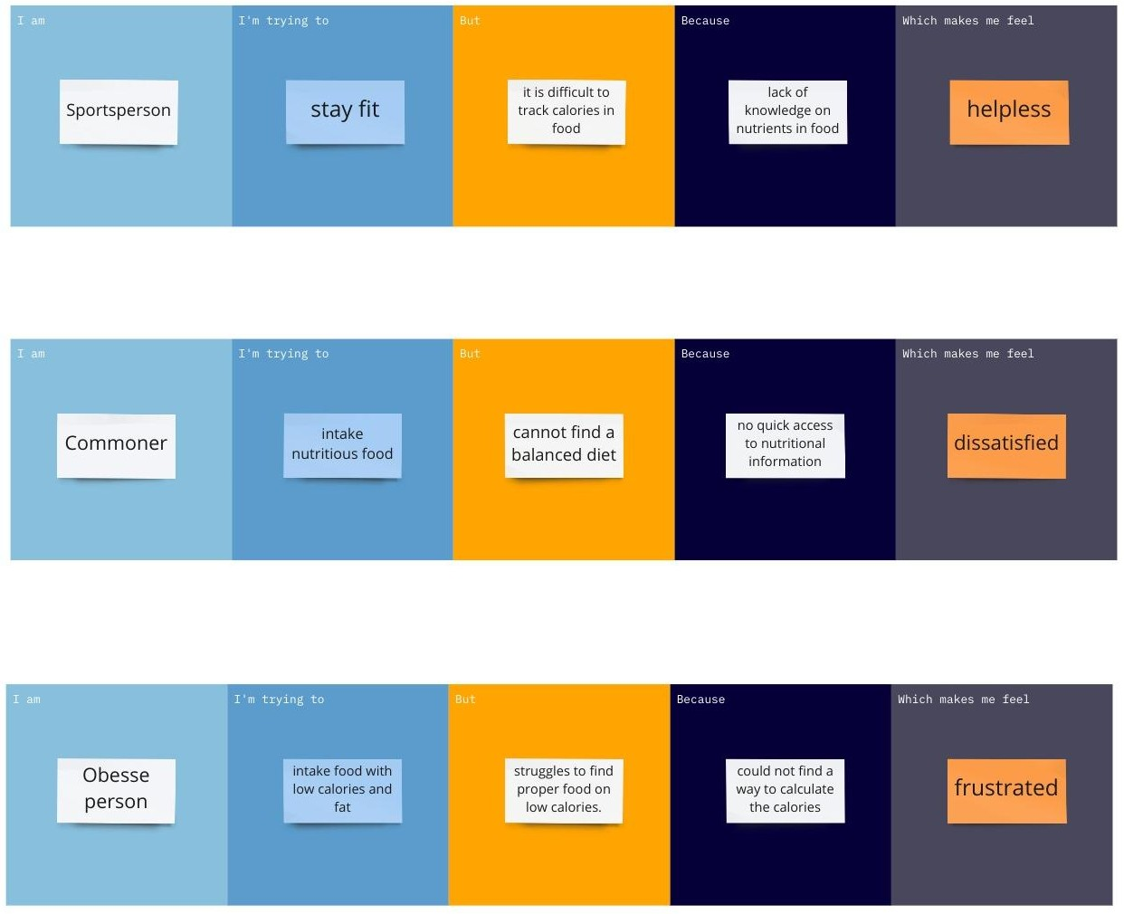

|  |  |  |  |  |  |
| --- | --- | --- | --- | --- | --- |
| **Problem Statement (PS)** | **I am**  **(Customer)** | **I’m trying to** | **But** | **Because** | **Which makes me feel** |
| PS-1 | Sportsperson | stay fit | it is difficult to track calories in  food | lack of knowledge on nutrients in food | helpless |
| PS-2 | Commoner | intake  nutritious food | cannot find a balanced diet | no quick access to nutritional  information | dissatisfied |
| PS-3 | Obesse Person | intake food with low  calories | struggles to find food on  low calories | could not find a way to calculate calories | dissatisfied |